Final Design: Project Nineveh
January 31, 2022

Team: 25
Members:
- Connor Sutton (2927058)
- Aidan Schmelzle (2927001)
- Daniel Johnson (2921401)
- Mason Hawks (2905101)
- Jacob Wagner (2921682)

Name: Project Nineveh

Synopsis: Roguelike video game influenced by cultures of the ancient Near East.

Description:
The goal of our project is to combine our varied, interdisciplinary interests and create a game set against the backdrop of the ancient Near East and the cultures of the Babylonians, Assyrians, Persians, etc. We hope to fully indulge in our creativity while drawing on inspiration from games such as Hades, Dead Cells, Cuphead as well as other forms of art. As is custom in the roguelike genre, we plan to use procedural generation to randomize the content and give the core of the game substantial replayability. The setting and story are inspired by the historical account of Xenophon, the Greek philosopher, historian, and general, and his encounter with the abandoned and forgotten city of Nineveh, the capital city of the largest empire the world had ever seen just 200 years before. Our game will focus on the ‘city gods’ of locations like Babylon and Nineveh, and the player character will fight to reestablish the dominance of a forgotten and jealous god.

Semester 1 Milestones:
- Planning [9/20 - 11/1]
- Research(maps, level design, character/boss design) [9/20 - 11/1]
- Art Development/Concepts [9/27 - 12/10]
- Game Prototyping [9/27 - 12/10]
Semester 2 Milestones:
- Initial development & implementation [1/17 - 2/7]
- Debugging/Reworking/Sounds & Effects [2/7 - 3/7]
- Minimum viable product [3/7 - 4/4]
- Extra development/add-ons [4/4 - 5/6]

Budget:
Music: Cost: ~$100 | Vendor: TBD | Date Required: Sound & Effects stage (2/7 – 3/7)
Steam Direct: Cost - $100 | Vendor: Steam | Date Required: Upon Completion (5/6)

Final Project Design:
Project Nineveh is a 2D roguelike video game in which the player ascends Etemenanki, the “House of the foundation of Heaven and Earth” in Babylon and the historical basis for the Tower of Babel, in an attempt to dispose with the god Marduk at the top. The term “roguelike” denotes a game characterized by progression through procedurally generated levels with permanent death of the player character. We chose this genre as it harmonized with our primary design principle: to maximize the amount of content with a minimal amount of resources. Our greatest design constraint is time; video games require visual art and animation, storytelling, music, and integration of these with the gameplay and mechanics. This demands a high volume of resources which could make delivering a finished, polished product within our window of time quite difficult. Because roguelike games use procedurally generated levels, however, a relatively small amount of effort can create a system that generates high variability in content. Additionally, the permanent death of the character means that player will be repeatedly proceeding through the same core content, randomly generated each time, rather than continuously moving on to new levels.
This allows us to focus on our second design principle: to create an obtainable core that can be used as a foundation for further development if time permits. When reviewing the projects from the previous year, there was a high degree of variation in the quality of video games. The characteristic sign of failure was the lack of a strong, developed, attainable goal devised in the initial stages of design. It was apparent to us that if we wanted to take on an ambitious, multidisciplinary project such as this, we must consider attainability in every aspect of design. These two design principles, formulated around overcoming our greatest design constraints, bleed through all components of our game.
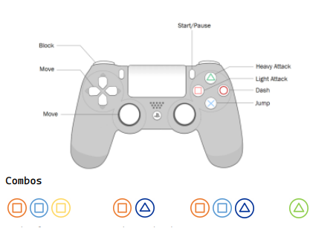
Video games are built on their artistic assets. Work must be done for the environment, background, characters, enemies, bosses, etc. A single animation may take anywhere from 5-15 separate drawings, and a single character may have 10 unique animations. In order to keep our project attainable, we have opted for an approach involving fewer characters with more depth. Our story and gameplay have been structured around the notion that we must keep the demand for artistic resources at a minimum. Our combat system, for example, will be slower but more deliberate than other roguelike systems seen in games like Dead Cells, where enemies are numerous, but each individual fight is short and fast. In order to use fewer enemies, our fights need to be longer and require more effort. To accomplish this, our combat system is built around learning exact timings of a variety of attacks; the player must understand the rhythm of each enemy in order to dispose of them. In this way, advanced players will breeze through sections that trouble beginners without having to deliberately increase the power of the player character.
Control configuration and outline of attack combos
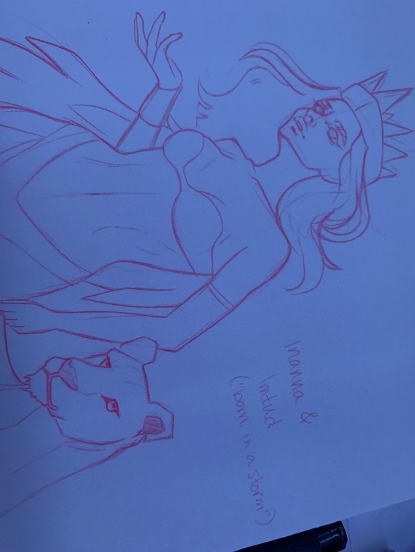
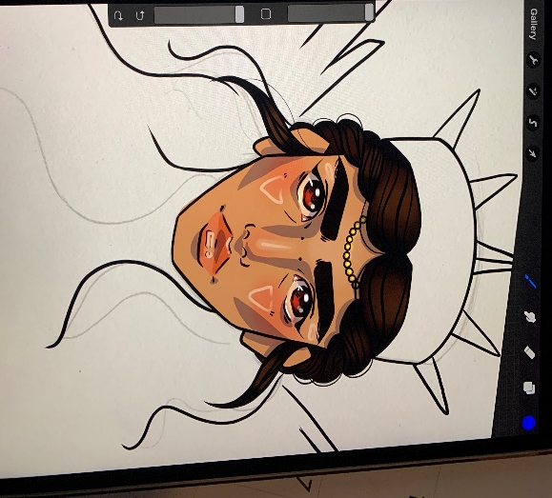
The story of our game too needed to use a minimal number of characters. We have the unnamed player character; Ashur, the city god of forgotten and abandoned Nineveh, the old capital of the Assyrian Empire; Marduk, city god of Babylon and supreme power over civilization in Mesopotamia; and Inanna or Ishtar, the Queen of Heaven. Our player character will come across the “ghost city” of Nineveh, vacant and forgotten as it was historically found by Xenophon. An attempt at exploration will result in accidental communion with Ashur, who enslaves and empowers us to dethrone Marduk on his behalf. As our character ascends the procedurally generated floors of Etemenanki, the ziggurat of Marduk, Inanna takes notice.
Concept art for Inanna, Queen of Heaven
As has been mentioned, we plan to use procedural generation to create the levels for Project Nineveh. This will allow us to create an immense amount of variability with a minimal number of assets. Using the configuration of levels illustrated below, eight room types can be used to stich together 102 distinct possibilities for an individual section.
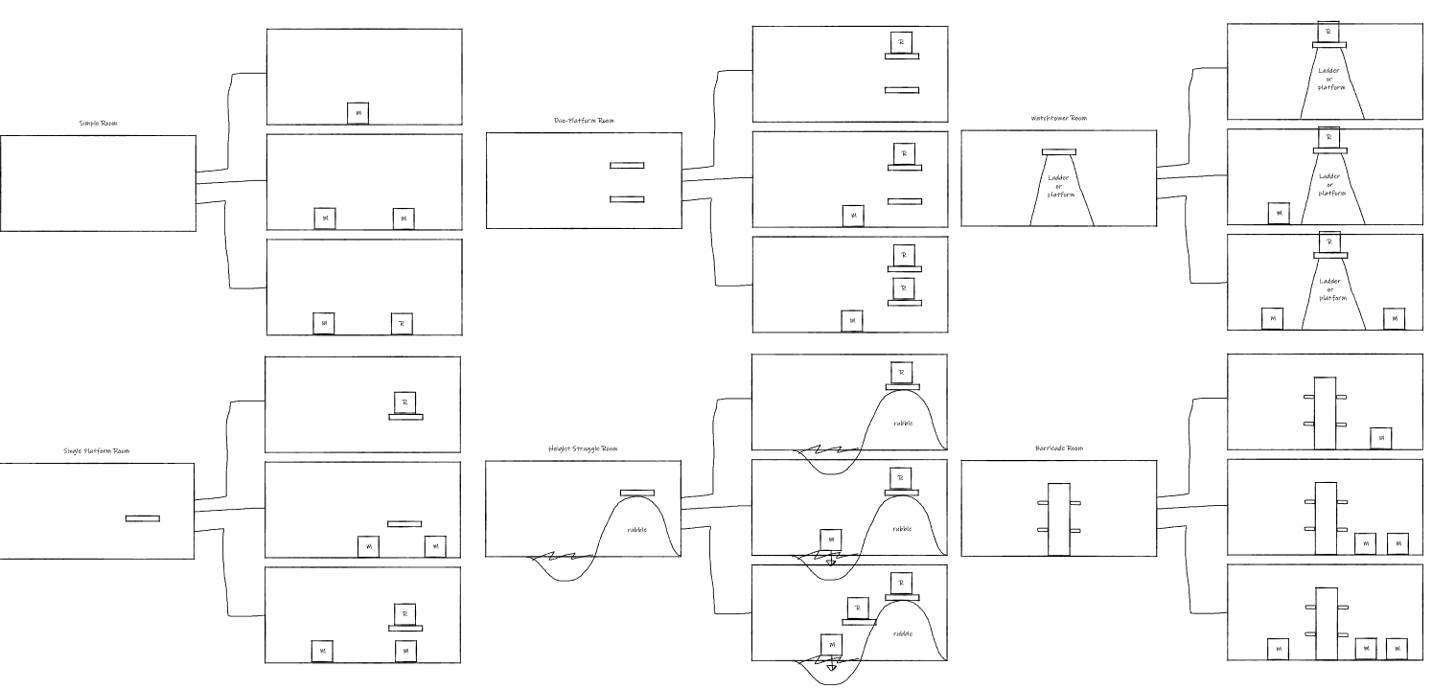
Potential configurations for a series of different types of rooms. Boxes represent enemies, with an ‘M’ standing for melee and ‘R’ for ranged.

There are a series of options we are currently exploring when it comes to the music to be used in the game. One potential method is the use of a generative AI model trained on traditional Near-Eastern music. While this method could produce very interesting results, it is not something on which we can comfortably rely. AI generated music may be unpredictable, and creating a sufficient model requires a dataset that may not be trivial to acquire. In the case that this method turns out insufficient, we can either turn to music in the public domain or make our own. It is probably that all three of these options will be explored, and the best results will be used.

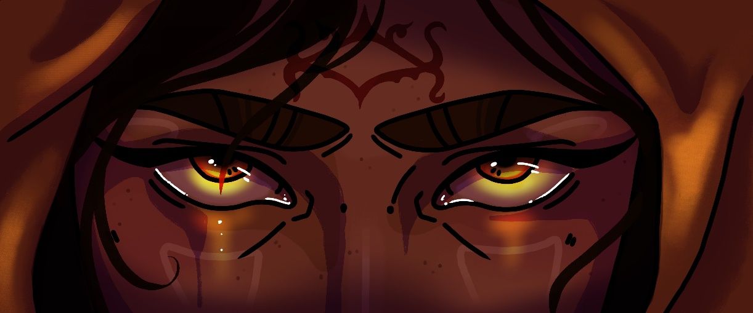

Concept art for the player character

To make our game, we opted to use the game engine Unity. We decided to use Unity over other options like unreal or Godot for several reasons. Firstly, Unreal is more catered towards 3D games while Unity has better 2D support. Although Godot is a great 2D engine, it requires the use of its own language GDScript. Finally, several of our group members have some experience with Unity already. Unity natively supports C#, so that is the language we will use to code with. As mentioned earlier, we decided on a 2D style. Specifically, we will be creating a scrolling game. The results of the level generation will be large, continuous scenes that are broken up into rooms through the use of camera transitions. Our characters will be created through the use of lower detail sprites with premade animations for all the actions. This version of the character will be used to explore the level. In dialogue, we will have a higher definition still image of the character overlaid with the text. This will give the player an accurate perception of how the character looks while cutting down on the time we need to spend on animating and creating art.

Ethical Issues:
- Representation: Our project is meant to depict ancient near east cultures while incorporating some liberties and fiction to keep it engaging. We must aim to keep a respectful and accurate representation of these cultures based on moral standards. For instance, if we were to take too many liberties in the depiction of their religions and our game got popular, this could be harmful to how these peoples should be remembered. Warping how people view history is not our goal, creating a fun experience based on overlooked mythology is. With this in mind, we should aim to base our depictions on the cultures accurately, then add on to and embellish certain aspects if needed.
- Addiction and monetization: Many video games today around all platforms have ethical problems stemming from addiction and monetization. The main ways to monetize a game are flat price, in-game advertisements, and microtransactions. Flat price was the standard for many years, but today many games have found it more profitable to include in-game ads and/or microtransactions in their business model. In-game ads are of less worry, but still in a grey ethical area due to how many ads people deal with on a regular basis. Depending on the system, microtransactions can be very predatory for games with scarce resources that can be bought with real-world money. These resource-scarce systems also many times foster addiction through rewards for playing regularly like daily quests and energy replenishment. With all of this in mind, we would choose the flat price method if we chose to monetize our title.

Intellectual Property Issues:

- Sound/music assets: For this project our team will be pulling from different audio and visual realms that we are not extremely familiar with. Because of this, we are trying to learn as much as possible about each asset and to pull ideas and methods from others who have created work in the past and have posted tutorials or templates for free use. We hope to be able to use skills that we have learned from others to create our own musical assets that will be utilized in our game. Our team members are creative and willing to learn new skills so trying to come up with creative assets should be an attainable goal.
- Assets in the public domain: Remembering the case studies we learned in the labs, our team is determined to ensure that we know the root of all the code that will be implemented in our game so no one’s intellectual property is stolen. Everyone on our team is excited to be working as a creator and we want to make sure that we are not stealing the hard work of another creator. We will be sure to thoroughly research the sources we are using and document them to give credit to original authors. Thanks to the labs and ethics lecture, we all know what to look for and should be able to easily navigate the field of intellectual property.

Change Log:

- Rewording of Description
- Updated Budget section based on new estimates given our current progress
- Updated Final Project Design section with current information
- Updated Final Project Design section with new illustrations
- Updated Gantt chart to show directives for the spring rather than for the fall. This included specifying the current jobs that must be implemented for each team member.
- Instead of attaching an image of the Gantt chart, a pdf was attached to the file as was detailed in the design rubric.

